**EXERCICE SUR LE CHANGEMENT D’ECHELLES TAILLE REDUITE**

%-----------------------------------------------------------

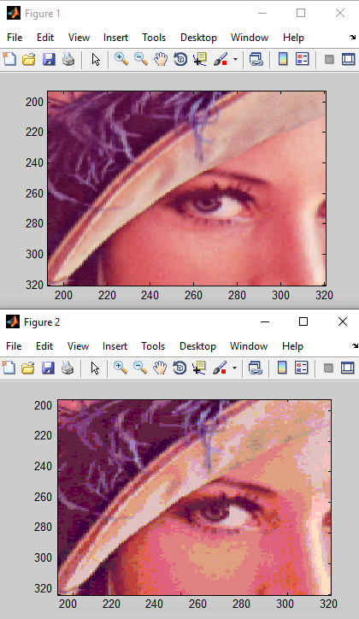

clc

close all

clear all

I= imread('Lena.bmp');

axis image

size(I)

figure(1),imagesc(I)

zoom(4);

R=double(I(:,:,1));

G=double(I(:,:,2));

B=double(I(:,:,3));

R=uint8(R/32); %CONSERVER LES 3 BITS MCB

G=uint8(G/32); %CONSERVER LES 3 BITS MCB

B=uint8(B/64);%CONSERVER LES 2 BITS MCB

Im(:,:,1)=R*32;

Im(:,:,2)=G*32;

Im(:,:,3)=B*64;

figure(2),imagesc(Im);

axis image

zoom(4);

size(Im)